Title of Thesis

*(Cover Page)*



Author(s)

Name of Student Student’s Registration Number

Name of Student Student’s Registration Number

Name of Student Student’s Registration Number

Name of Student Student’s Registration Number

Supervisor

Name of Supervisor

Supervisor’s Designation

DEPARTMENT OF ELECTRICAL ENGINEERING

ARMY PUBLIC COLLEGE of MANGAEMENT AND SCIENCES

Affiliated with

UNIVERSITY OF ENGINEERING AND TECHNOLOGY

TAXILA

Month Year

Thesis Title

*(Inside First page)*

Author

Name of Student

Student’s Registration Number

A thesis submitted in partial fulfillment of the requirements for the degree of

B.Sc. Electrical Engineering

Thesis Supervisor:

Supervisor Name

Designation & Department

External Examiner Signature:

Thesis Supervisor Signature:

DEPARTMENT OF ELECTRICAL ENGINEERING

ARMY PUBLIC COLLEGE of MANGAEMENT AND SCIENCES

Affiliated with

UNIVERSITY OF ENGINEERING AND TECHNOLOGY

TAXILA

Month Year

Abstract

Write abstract from here. The font of the entire document is Times New Roman size 12, regular, justified except headings. The length of the abstract should not exceed 1 page at maximum.

Keywords:

# UNdertaking

Use the following undertaking as it is.

I certify that research work titled “*enter title of your research proposal here*” is my own work. The work has not been presented elsewhere for assessment. Where material has been used from other sources it has been properly acknowledged / referred.

Signature of Student

Name of Student

Registration Number

Signature of Student

Name of Student

Registration Number

Signature of Student

Name of Student

Registration Number

Signature of Student

Name of Student

Registration Number

# Acknowledgements

*Write acknowledgment here. Use Times New Roman 12, Italic, justified.*

# Table of Contents

Sample is given below:

Abstract ………...ii

Acknowledgement iii

List of Figures vi

List of Tables vii

Abbreviations viii

Chapter I: Introduction 1

1.1 Statement of the Problem 1

1.2 Objectives 3

1.3 Organization of the Thesis 3

Chapter II: Overview of xyz scheme……………………………………... 4

# List of figures

Sample is given below:

*Number Page*

Fig 2.1Block diagram of xyz block 8

Fig 2.2 Basis Functions Diagram 9

Fig 2.3 Block Diagram of Codec 10

Fig 3.1Encoder 13

Fig 3.2 Decoder. 14

# List of tables

Similar to the list of figures.

# Chapter 1

**Name of Chapter**

* 1. **Heading 1**

All main headings in Times New Roman font size 14, bold. All the text in Times New Roman font size12, regular, justified & in double line spacing format.

* + 1. **Subheading 1**

All subheadings in Times New Roman font size 12, bold.

* + - 1. **Subheading 2**
  1. **Heading 2**

# Chapter 2

**Name of Chapter 2**

**2.1 Figure Style**

All figures should be centrally aligned with captions at bottom of figure.

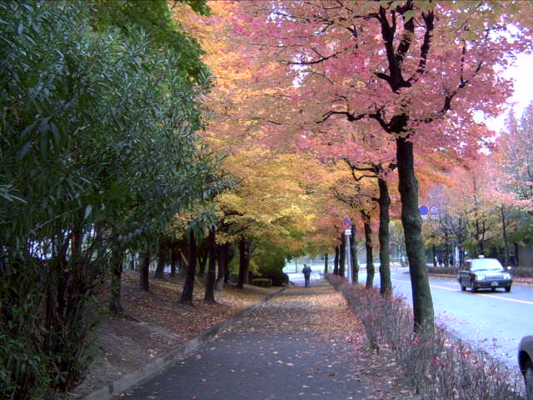

Fig 2.1**:** Autumn in Osaka, Japan

**2.2 Table Style**

All tables should be centrally aligned with captions at the top as sample given below:

Table 2.1: xyz

|  |  |  |  |
| --- | --- | --- | --- |
| 1 |  |  |  |
| 2 |  |  |  |

**2.3 Equations Style**

All equations should be centrally aligned with proper numbering. Use Microsoft Word Equation Editor. E.g.,

 (2.1)

# **CONCLUSION**

Write conclusion of your thesis here. Maximum of 1 page.

**REFERENCES**

Use following style format for references.

***Example Journal Paper:***

1. Zar Khitab, “Review: Review: Dual polarization dopplers radars technlogy,” *Communications ACM*, vol. 34, no. 4, pp. 46–58, April 2009.

***Example Conference Paper:***

1. Zar Khitab and F.A. Bhatti, “New technique: cross polarization reduction in dual polarization Doppler RADARs,” in *Proc. 7th IEEE International Symposium on Communications & Information Technologies, ISCIT 04*, Sapporo, Japan, 2015, pp. 743–746.

***Example Book:***

1. Iain E.G. Richardson, *Video Codec Design*, Great Britain, John Wiley & Sons, 2003, ISBN: xx-yyyy-zzzz.

***Example Web Link:***

[4] MPEG Software Simulation Group, “The MSSG homepage”, available on-line at

[http://www.mpeg.org/MPEG/ MSSG](http://www.mpeg.org/MPEG/%20%20MSSG), 2004.

***Example Standard:***

[5]ITU-T “Video Coding for low bit rate communication,” ITU-T Recommendation

H.263; version 1, Nov 1995; version 2, Jan. 1998; version 3, Nov. 2000.

# Abbreviations

Abbreviations should be placed at the end. Sample is given below:

**BTTP:** B Sc Thesis Topic Proposal

**EED:** Electrical Engineering Department

# Annexure

Annexure (if any) should be placed at the end of thesis report.

***Hard Copy Information****:*

Page Size: Letter (8.5” x 11”)

Page Margins: Top & Bottom = 1” and Left & Right = 1.25”

Page orientation: Portrait

Line Spacing: Double

Page Numbering: Bottom Center

Printing: One Side

***Note about Binding*:**

**Four** hard bound copies of the thesis are to be submitted for final thesis examination. Hard bound means permanently stitched and bound in **MAROON COVER** with the title of the dissertation and your name(s) clearly inscribed on the cover as per format given at the first page of template in **GOLDEN** color. The **SPINE** of thesis title **and Year**.